**ASSIGNMENT – 25.1**

**Problem statement:**

1. Write a Hive program to find the number of medals won by each country in swimming.
2. Write a Hive program to find the number of medals that India won year wise.

**Input Data Set:**

<https://d3rzweswlj42yv.cloudfront.net/course/bigdatadeveloper/project/olympic_data.csv>

**Output:**

Creating table Olympics in custom database and loading Olympics data into the table:

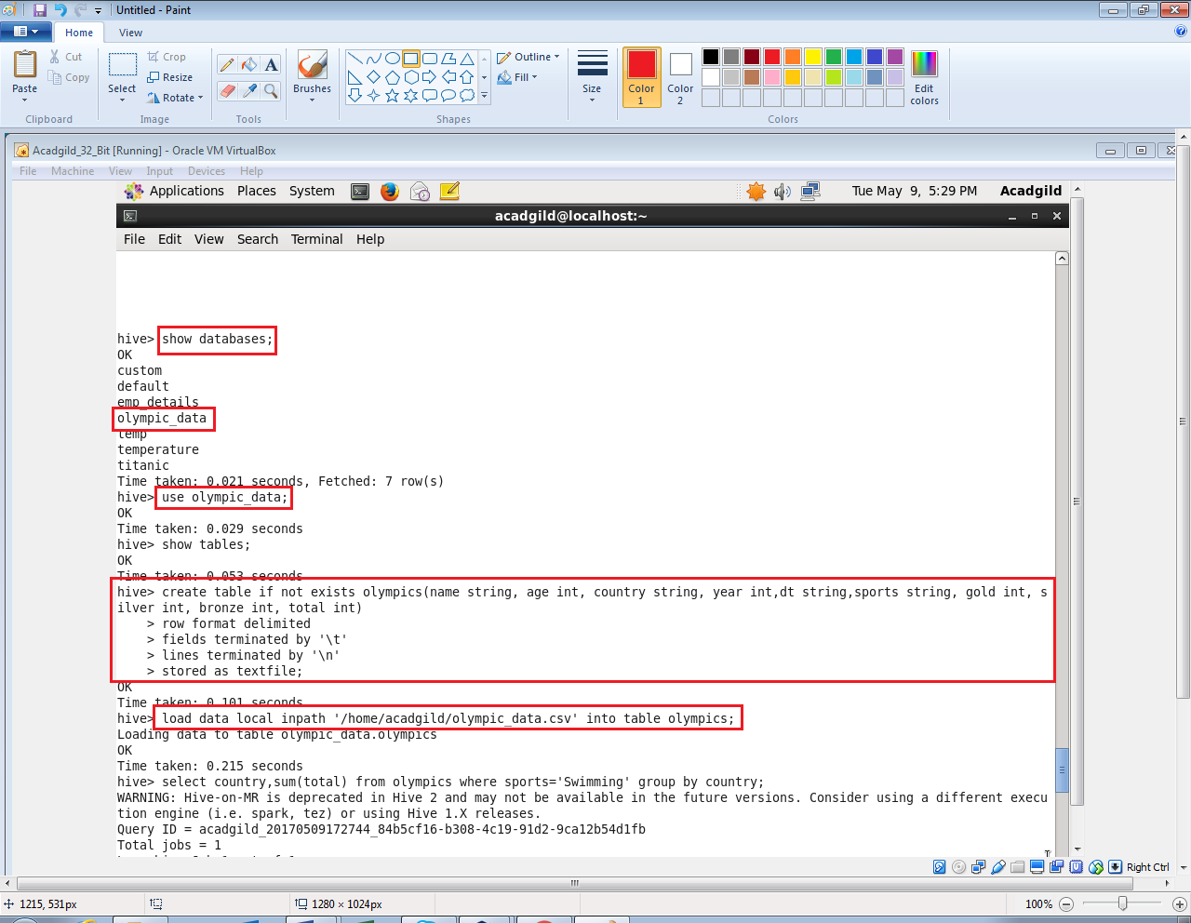

**Problem 1:**

* Write a Hive program to find the number of medals won by each country in swimming.

**Output 1:**

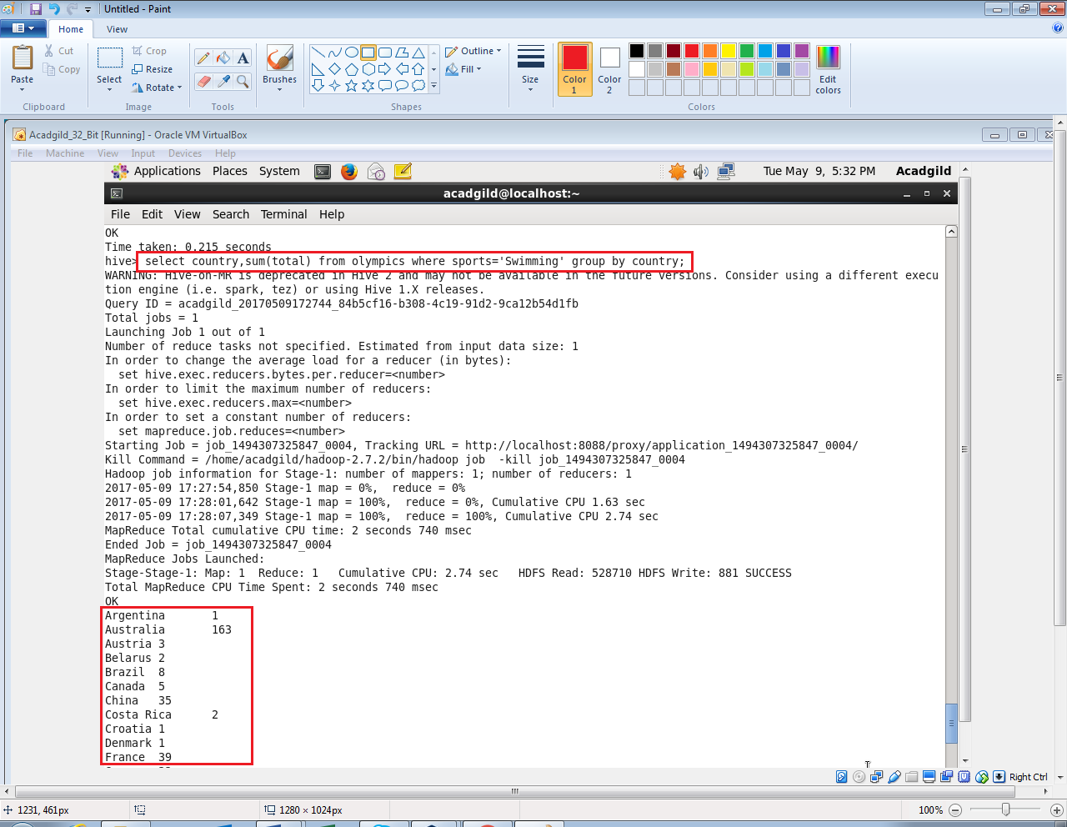

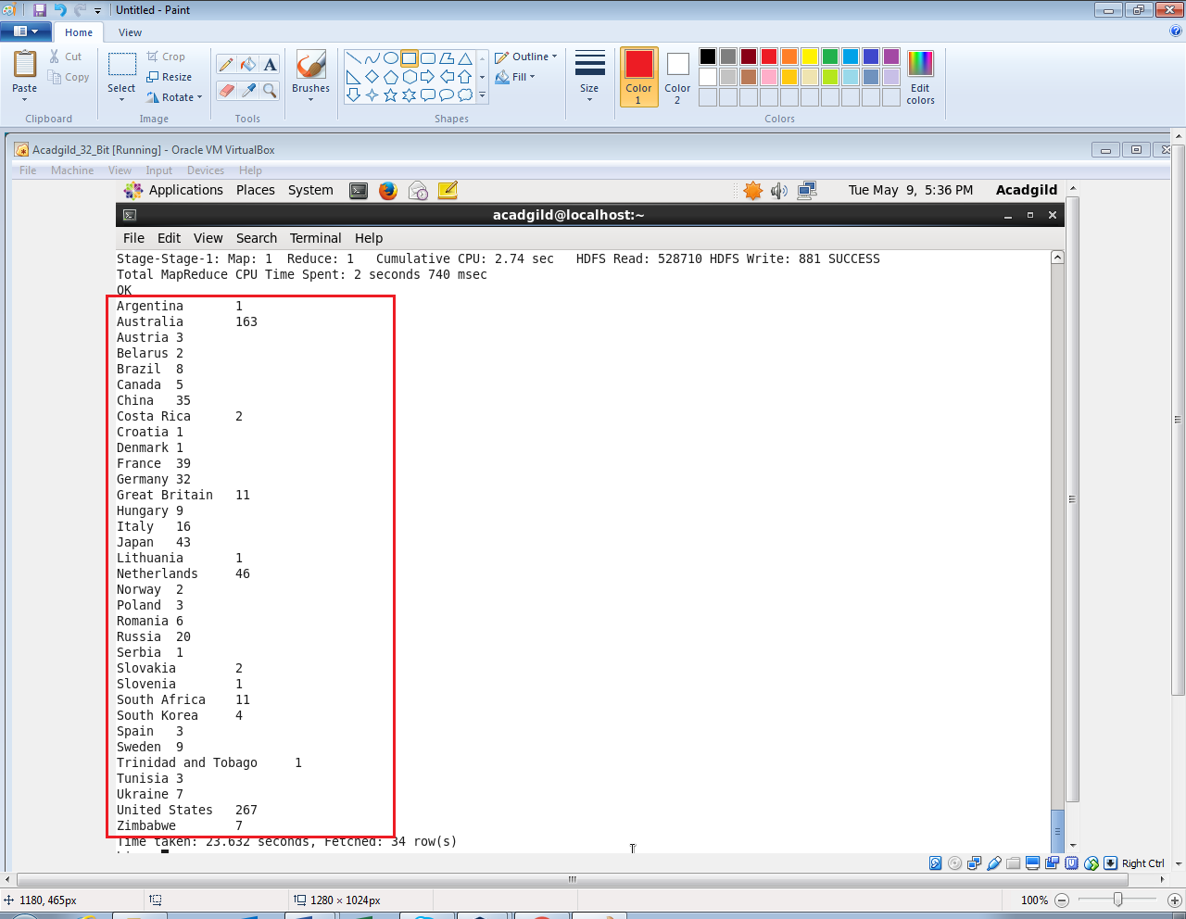

**Problem 2:**

Write a Hive program to find the number of medals that India won year wise.

**Output 2:**

